Design and Analysis of Algorithms Programs for Turbo C
1. Binary Search
#include<stdio.h>
#include<conio.h>
void main(){
int a[10], n, i, low, high, mid, key, found=0;
clrscr();
printf("Enter number of elements: ");
scanf("%d",&n);
printf("Enter sorted elements:\n");
for(i=0;i<n;i++){
scanf("%d",&a[i]);
}
printf("Enter element to search: ");
scanf("%d",&key);
low=0;
high=n-1;
while(low<=high){
mid=(low+high)/2;
if(a[mid]==key){
found=1;
break;
}
else if(a[mid]<key){
low=mid+1;
}
else{
high=mid-1;
}
}
if(found)
printf("Element found at position %d",mid+1);
else
printf("Element not found");
getch();
}
Output:
Enter number of elements: 5
Enter sorted elements:
10 20 30 40 50
Enter element to search: 30
Element found at position 3
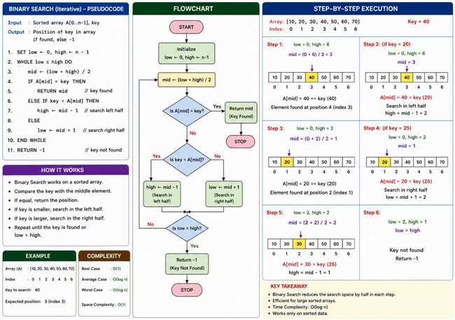

2. Linear Search
#include<stdio.h>
#include<conio.h>
void main(){
int a[100], n, i, key, found = 0;
clrscr();
printf("Enter number of elements: ");
scanf("%d", &n);
printf("Enter elements:\n");
for(i=0; i<n; i++){
scanf("%d", &a[i]);
}
printf("Enter element to search: ");
scanf("%d", &key);
for(i=0; i<n; i++){
if(a[i] == key){
found = 1;
break;
}
}
if(found)
printf("Element found at position %d", i+1);
else
printf("Element not found");
getch();
}

Output: Enter number of elements: 5
Enter elements:
10 25 30 45 50
Enter element to search: 45
Element found at position 4

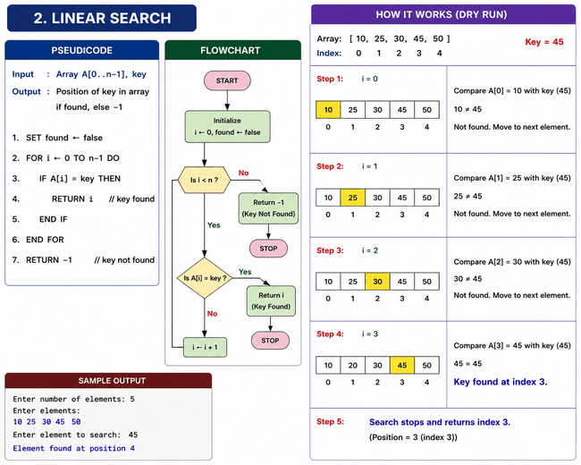

3. Bubble Sort
#include<stdio.h>
#include<conio.h>
void main(){
int a[100], n, i, j, temp;
clrscr();
printf("Enter number of elements: ");
scanf("%d", &n);
printf("Enter elements:\n");
for(i=0; i<n; i++)
scanf("%d", &a[i]);
for(i=0; i<n-1; i++){
for(j=0; j<n-i-1; j++){
if(a[j] > a[j+1]){
temp = a[j];
a[j] = a[j+1];
a[j+1] = temp;
}
}
}
printf("Sorted elements:\n");
for(i=0; i<n; i++)
printf("%d ", a[i]);
getch();
}
Output: Enter number of elements: 5
Enter elements:
50 20 40 10 30
Sorted elements:
10 20 30 40 50

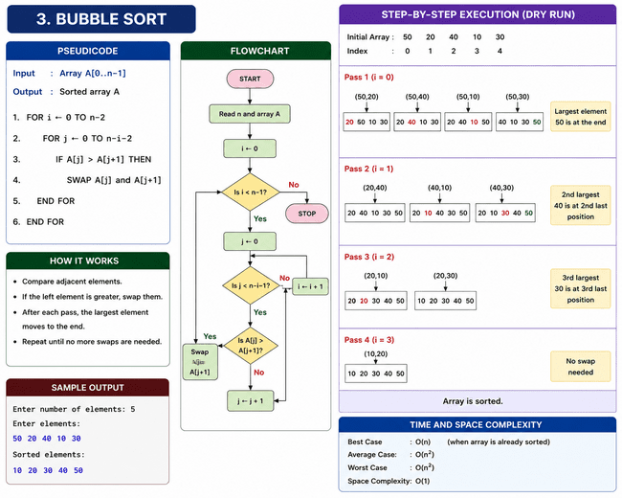

4. Selection Sort
#include<stdio.h>
#include<conio.h>
void main(){
int a[100], n, i, j, min, temp;
clrscr();
printf("Enter number of elements: ");
scanf("%d", &n);
printf("Enter elements:\n");
for(i=0; i<n; i++)
scanf("%d", &a[i]);
for(i=0; i<n-1; i++){
min = i;
for(j=i+1; j<n; j++){
if(a[j] < a[min])
min = j;
}
temp = a[i];
a[i] = a[min];
a[min] = temp;
}
printf("Sorted elements:\n");
for(i=0; i<n; i++)
printf("%d ", a[i]);
getch();
}
Output: Enter number of elements: 5
Enter elements:
64 25 12 22 11
Sorted elements:
11 12 22 25 64
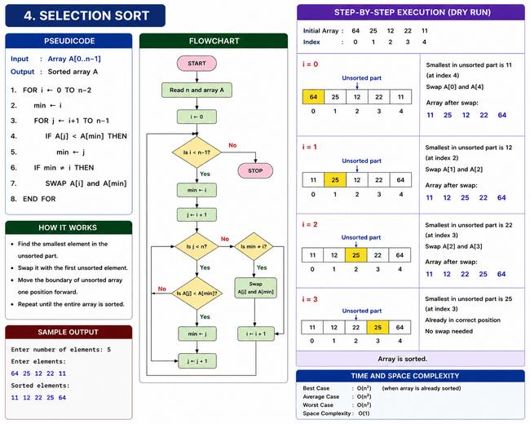

5. Insertion Sort, Iterative
#include<stdio.h>
#include<conio.h>
void main(){
int a[100], n, i, j, key;
clrscr();
printf("Enter number of elements: ");
scanf("%d",&n);
printf("Enter elements:\n");
for(i=0;i<n;i++)
scanf("%d",&a[i]);
for(i=1;i<n;i++){
key=a[i];
j=i-1;
while(j>=0 && a[j]>key){
a[j+1]=a[j];
j--;
}
a[j+1]=key;
}
printf("Sorted elements:\n");
for(i=0;i<n;i++)
printf("%d ",a[i]);
getch();
}
Output: Enter number of elements: 5
Enter elements:
12 11 13 5 6
Sorted elements:
5 6 11 12 13
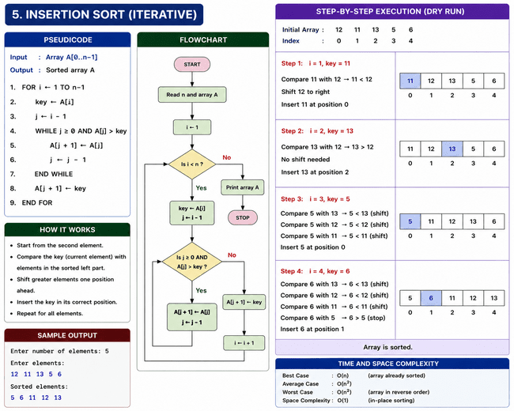
6. Shell Sort, Iterative
#include<stdio.h>
#include<conio.h>
void main(){
int a[100], n, i, j, gap, temp;
clrscr();
printf("Enter number of elements: ");
scanf("%d",&n);
printf("Enter elements:\n");
for(i=0;i<n;i++)
scanf("%d",&a[i]);
for(gap=n/2; gap>0; gap=gap/2){
for(i=gap; i<n; i++){
temp=a[i];
for(j=i; j>=gap && a[j-gap]>temp; j=j-gap){
a[j]=a[j-gap];
}
a[j]=temp;
}
}
printf("Sorted elements:\n");
for(i=0;i<n;i++)
printf("%d ",a[i]);
getch();
}

Output
Enter number of elements: 5
Enter elements:
45 23 12 89 1
Sorted elements:
1 12 23 45 89
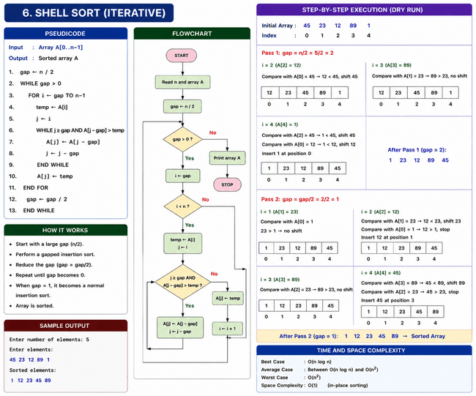

7. Merge Sort
#include<stdio.h>
#include<conio.h>
int a[50];
void merge(int low,int mid,int high){
int h,i,j,b[50],k;
h=low;
i=low;
j=mid+1;
while((h<=mid)&&(j<=high)){
if(a[h]<=a[j]){
b[i]=a[h];
h++;
}
else{
b[i]=a[j];
j++;
}
i++;
}
if(h>mid){
for(k=j;k<=high;k++){
b[i]=a[k];
i++;
}
}
else{
for(k=h;k<=mid;k++){
b[i]=a[k];
i++;
}
}
for(k=low;k<=high;k++)
a[k]=b[k];
}
void mergesort(int low,int high){
int mid;
if(low<high){
mid=(low+high)/2;
mergesort(low,mid);
mergesort(mid+1,high);
merge(low,mid,high);
}
}
void main(){
int n,i;
clrscr();
printf("Enter number of elements: ");
scanf("%d",&n);
printf("Enter elements:\n");
for(i=0;i<n;i++)
scanf("%d",&a[i]);
mergesort(0,n-1);
printf("Sorted elements:\n");
for(i=0;i<n;i++)
printf("%d ",a[i]);
getch();
}
Output: Enter number of elements: 5
Enter elements:
50 20 40 10 30
Sorted elements:
10 20 30 40 50
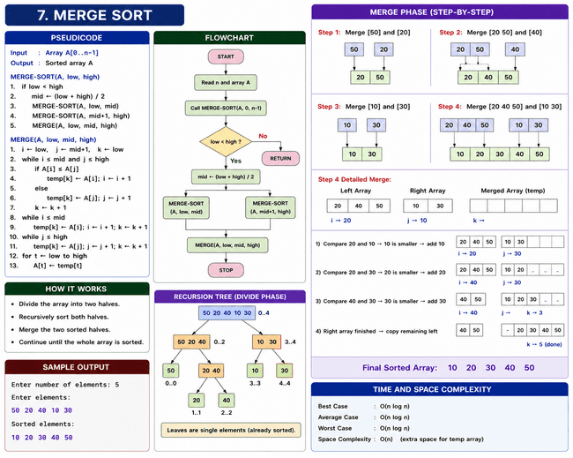

8. Quick Sort
#include<stdio.h>
#include<conio.h>
int partition(int a[],int low,int high){
int pivot,i,j,temp;
pivot=a[low];
i=low+1;
j=high;
while(i<=j) {
while(a[i]<=pivot && i<=high)
i++;
while(a[j]>pivot)
j--;
if(i<j){
temp=a[i];
a[i]=a[j];
a[j]=temp;
}
}
temp=a[low];
a[low]=a[j];
a[j]=temp;
return j;
}
void quicksort(int a[],int low,int high){
int p;
if(low<high){
p=partition(a,low,high);
quicksort(a,low,p-1);
quicksort(a,p+1,high);
}
}
void main(){
int a[20],n,i;
clrscr();
printf("Enter number of elements: ");
scanf("%d",&n);
printf("Enter elements:\n");
for(i=0;i<n;i++)
scanf("%d",&a[i]);
quicksort(a,0,n-1);
printf("Sorted elements:\n");
for(i=0;i<n;i++)
printf("%d ",a[i]);
getch();
}
Enter number of elements: 5
Enter elements:
45 20 10 50 30
Sorted elements:
10 20 30 45 50

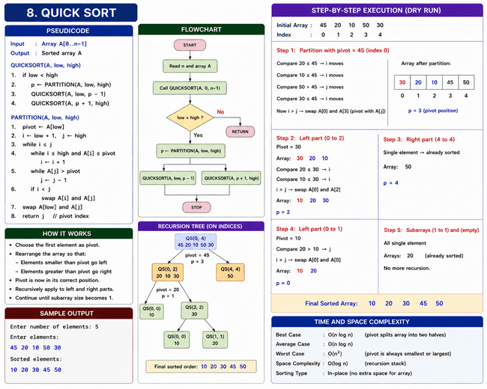

9. Heap Sort
#include<stdio.h>
#include<conio.h>
void heapify(int a[], int n, int i){
int largest=i;
int left=2*i+1;
int right=2*i+2;
int temp;
if(left<n && a[left]>a[largest])
largest=left;
if(right<n && a[right]>a[largest])
largest=right;
if(largest!=i){
temp=a[i];
a[i]=a[largest];
a[largest]=temp;
heapify(a,n,largest);
}
}
void heapsort(int a[], int n){
int i, temp;
for(i=n/2-1;i>=0;i--)
heapify(a,n,i);
for(i=n-1;i>=0;i--){
temp=a[0];
a[0]=a[i];
a[i]=temp;

heapify(a,i,0);
}
}
void main(){
int a[20],n,i;
clrscr();
printf("Enter number of elements: ");
scanf("%d",&n);
printf("Enter elements:\n");
for(i=0;i<n;i++)
scanf("%d",&a[i]);
heapsort(a,n);
printf("Sorted elements:\n");
for(i=0;i<n;i++)
printf("%d ",a[i]);
getch();
}
Enter number of elements: 5
Enter elements:
40 10 30 50 20
Sorted elements:
10 20 30 40 50
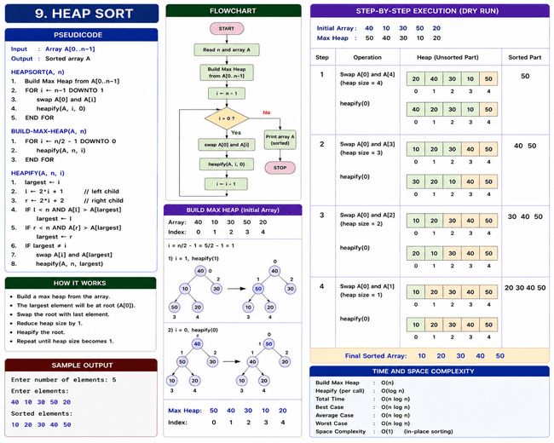

10. Dijkstra Algorithm
#include<stdio.h>
#include<conio.h>
#define MAX 10
void main(){
int cost[MAX][MAX],dist[MAX],visited[MAX];
int i,j,n, start,nextnode,mindist;
clrscr();
printf("Enter number of vertices: ");
scanf("%d",&n);
printf("Enter cost matrix:\n");
for(i=0;i<n;i++){
for(j=0;j<n;j++){
scanf("%d",&cost[i][j]);
if(cost[i][j]==0)
cost[i][j]=INF;
}
}
printf("Enter starting node: ");
scanf("%d",&start);
for(i=0;i<n;i++){
dist[i]=cost[start][i];
visited[i]=0;
}
dist[start]=0;
visited[start]=1;
for(i=1;i<n-1;i++){
mindist=INF
for(j=0;j<n;j++){
if(dist[j]<mindist && !visited[j]){
mindist=dist[j];
nextnode=j;
}
}
visited[nextnode]=1;
for(j=0;j<n;j++){
if(!visited[j]){
if(mindist+cost[nextnode][j]<dist[j]) {
dist[j]=mindist+cost[nextnode][j];
}
}
}
}
printf("Shortest distances:\n");
for(i=0;i<n;i++){
printf("%d -> %d = %d\n",start,i,dist[i]);
}
getch();
}
Enter number of vertices: 4
Enter cost matrix:
0 2 4 0
2 0 1 7
4 1 0 3
0 7 3 0
Enter starting node: 0
Shortest distances:
0 -> 0 = 0
0 -> 1 = 2
0 -> 2 = 3
0 -> 3 = 6

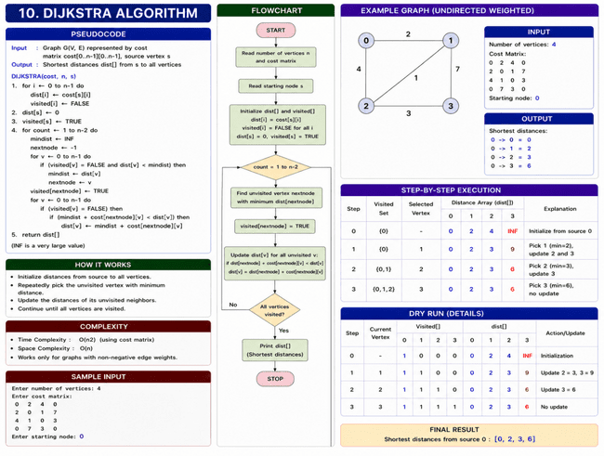

11. Kruskal Algorithm
#include<stdio.h>
#include<conio.h>
int parent[10];
int find(int i){
while(parent[i])
i=parent[i];
return i;
}
int uni(int i,int j){
if(i!=j){
parent[j]=i;
return 1;
}
return 0;
}
void main(){
int cost[10][10],i,j,n,min,a,b,u,v,ne=1,mincost=0;
clrscr();
printf("Enter number of vertices: ");
scanf("%d",&n);
printf("Enter cost matrix:\n");
for(i=1;i<=n;i++){
for(j=1;j<=n;j++){
scanf("%d",&cost[i][j]);
if(cost[i][j]==0)
cost[i][j]=999;
}
}
while(ne<n){
min=999;
for(i=1;i<=n;i++){
for(j=1;j<=n;j++){
if(cost[i][j]<min){
min=cost[i][j];
a=u=i;
b=v=j;
}
}
}
u=find(u);
v=find(v);
if(uni(u,v))
{
printf("\nEdge %d:(%d,%d) cost=%d",ne++,a,b,min);
mincost+=min;
}
cost[a][b]=cost[b][a]=999;
}
printf("\nMinimum cost = %d",mincost);
getch();
}
Enter number of vertices: 4
Enter cost matrix:
0 2 0 6
2 0 3 8
0 3 0 0
6 8 0 0

Edge 1:(1,2) cost=2
Edge 2:(2,3) cost=3
Edge 3:(1,4) cost=6
Minimum cost = 11

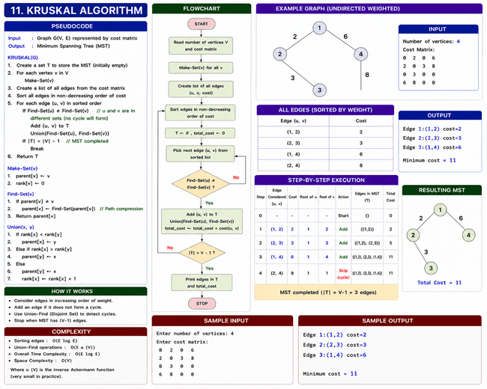

12. Prim Algorithm
#include<stdio.h>
#include<conio.h>
void main(){
int cost[10][10],visited[10]={0};
int i,j,n,ne=1,min,mincost=0,a,b;
clrscr();
printf("Enter number of vertices: ");
scanf("%d",&n);
printf("Enter cost matrix:\n");
for(i=1;i<=n;i++){
for(j=1;j<=n;j++){
scanf("%d",&cost[i][j]);
if(cost[i][j]==0)
cost[i][j]=999;
}}
visited[1]=1;
while(ne<n){
min=999;
for(i=1;i<=n;i++){
for(j=1;j<=n;j++){
if(cost[i][j]<min){
if(visited[i]!=0){
min=cost[i][j];
a=i;
b=j;
}
}
}
}
if(visited[b]==0){
printf("\nEdge %d:(%d %d) cost=%d",ne++,a,b,min);
mincost+=min;
visited[b]=1;
}
cost[a][b]=cost[b][a]=999;
}
printf("\nMinimum cost=%d",mincost);
getch();
}
Enter number of vertices: 4
Enter cost matrix:
0 2 0 6
2 0 3 8
0 3 0 0
6 8 0 0

Edge 1:(1 2) cost=2
Edge 2:(2 3) cost=3
Edge 3:(1 4) cost=6
Minimum cost=11

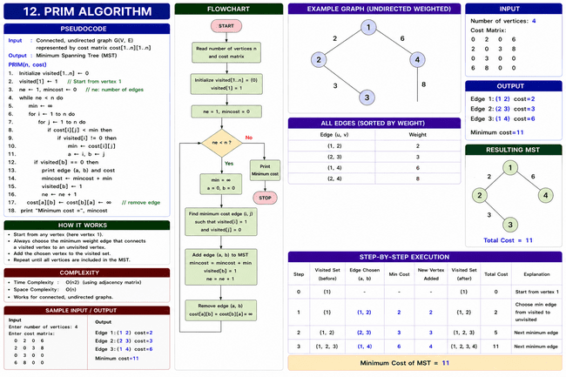

13. fractional knapsack
#include<stdio.h>
#include<conio.h>
void main(){
int i, j, n, temp;
int weight[20], profit[20], capacity;
float ratio[20], total = 0;
clrscr();
printf("Enter number of items: ");
scanf("%d", &n);
printf("Enter profits and weights:\n");
for(i=0; i<n; i++){
scanf("%d%d", &profit[i], &weight[i]);
ratio[i] = (float)profit[i] / weight[i];
}
printf("Enter capacity: ");
scanf("%d", &capacity);
for(i=0; i<n; i++){
for(j=i+1; j<n; j++){
if(ratio[i] < ratio[j]){
temp = profit[i];
profit[i] = profit[j];
profit[j] = temp;
temp = weight[i];
weight[i] = weight[j];
weight[j] = temp;
ratio[i] = (float)profit[i] / weight[i];
ratio[j] = (float)profit[j] / weight[j];
}
}
}
for(i=0; i<n; i++){
if(weight[i] <= capacity){
total += profit[i];
capacity -= weight[i];
}
else
{
total += ratio[i] * capacity;
break;
}
}
printf("Maximum Profit = %.2f", total);
getch();
}
Output: Enter number of items: 3
Enter profits and weights:
60 10
100 20
120 30
Enter capacity: 50
Maximum Profit = 240.00
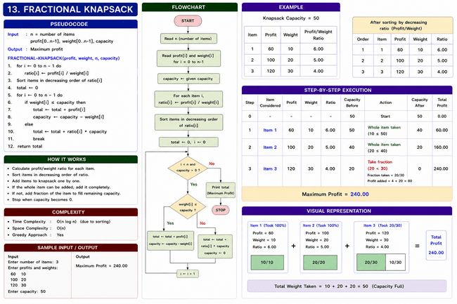
14. 0/1 Knapsack
#include<stdio.h>
#include<conio.h>
void main()
{
int i, j, n, m;
int w[10], p[10], k[10][10];
clrscr();
printf("Enter number of items: ");
scanf("%d", &n);
printf("Enter profits:\n");
for(i=1; i<=n; i++)
scanf("%d", &p[i]);
printf("Enter weights:\n");
for(i=1; i<=n; i++)
scanf("%d", &w[i]);
printf("Enter capacity: ");
scanf("%d", &m);
for(i=0; i<=n; i++)
{
for(j=0; j<=m; j++)
{
if(i==0 || j==0)
k[i][j] = 0;
else if(w[i] <= j)
{
if(p[i] + k[i-1][j-w[i]] > k[i-1][j])
k[i][j] = p[i] + k[i-1][j-w[i]];
else
k[i][j] = k[i-1][j];
}
else
k[i][j] = k[i-1][j];
}
}
printf("Maximum Profit = %d", k[n][m]);
getch();
}
Output: Enter number of items: 3
Enter profits:
60 100 120
Enter weights:
10 20 30
Enter capacity: 50
Maximum Profit = 220
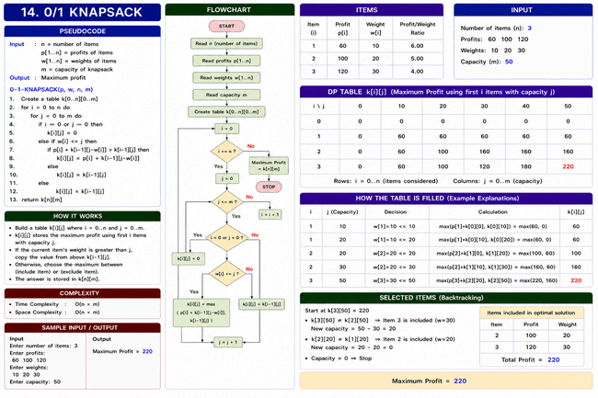

15. Floyd Warshall Algorithm
#include<stdio.h>
#include<conio.h>
void main()
{
int a[10][10], n;
int i, j, k;
clrscr();
printf("Enter number of vertices: ");
scanf("%d", &n);
printf("Enter cost matrix:\n");
for(i=0; i<n; i++)
{
for(j=0; j<n; j++)
{
scanf("%d", &a[i][j]);
}
}
for(k=0; k<n; k++)
{
for(i=0; i<n; i++)
{
for(j=0; j<n; j++)
{
if(a[i][j] > a[i][k] + a[k][j])
a[i][j] = a[i][k] + a[k][j];
}
}
}
printf("Shortest Path Matrix:\n");
for(i=0; i<n; i++)
{
for(j=0; j<n; j++)
{
printf("%d ", a[i][j]);
}
printf("\n");
}
getch();
}
Enter number of vertices: 4
Enter cost matrix:
0 5 999 10
999 0 3 999
999 999 0 1
999 999 999 0

Shortest Path Matrix:
0 5 8 9
999 0 3 4
999 999 0 1
999 999 999 0

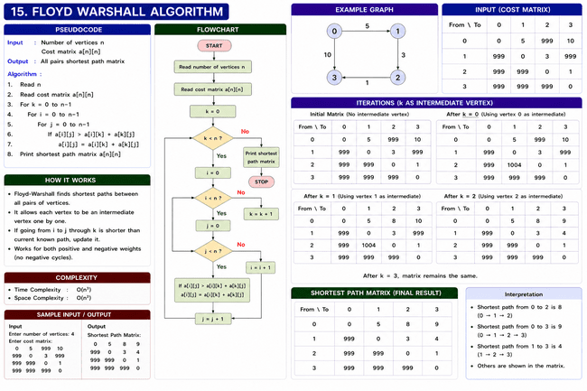

16. N Queen Problem
#include<stdio.h>
#include<conio.h>
#include<stdlib.h>
int x[10], count = 0;
int place(int k, int i)
{
int j;
for(j=1; j<k; j++)
{
if(x[j] == i || abs(x[j]- i) == abs(j- k))
return 0;
}
return 1;
}
void nqueen(int k, int n)
{
int i, j;
for(i=1; i<=n; i++)
{
if(place(k, i))
{
x[k] = i;
if(k == n)
{
count++;
printf("\nSolution %d:\n", count);

for(j=1; j<=n; j++)
printf("%d ", x[j]);
}
else
{
nqueen(k+1, n);
}
}
}
}
void main(){algorithm
int n;
clrscr();
printf("Enter number of queens: ");
scanf("%d", &n);
nqueen(1, n);
getch();
}
Enter number of queens: 4
Solution 1:
2 4 1 3
Solution 2:
3 1 4 2
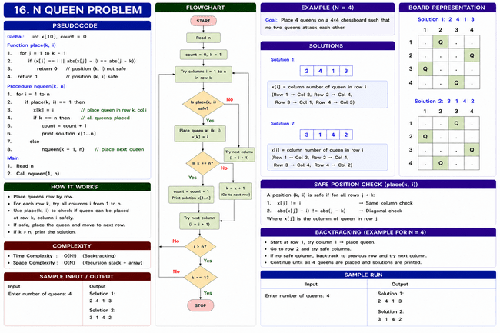

17. Hamiltonian Cycle
#include<stdio.h>
#include<conio.h>
int x[10],g[10][10],n;
void nextvalue(int k){
int j;
while(1){
x[k]=(x[k]+1)%(n+1);
if(x[k]==0)
return;
if(g[x[k-1]][x[k]]!=0){
for(j=1;j<=k-1;j++){
if(x[j]==x[k])
break;
}
if(j==k){
if((k<n) || (k==n && g[x[n]][x[1]]!=0))
return;
}
}
}
}

void hamiltonian(int k){
while(1)
{
nextvalue(k);
if(x[k]==0)
return;
if(k==n)
{
int i;
printf("\nCycle: ");
for(i=1;i<=n;i++)
printf("%d ",x[i]);
printf("%d",x[1]);
}
else
{
hamiltonian(k+1);
}
}
}

void main(){
int i,j;
clrscr();
printf("Enter number of vertices: ");
scanf("%d",&n);

printf("Enter adjacency matrix:\n");
for(i=1;i<=n;i++)
{
for(j=1;j<=n;j++)
{
scanf("%d",&g[i][j]);
}
}
for(i=1;i<=n;i++)
x[i]=0;
x[1]=1;
hamiltonian(2);
getch();
}
Enter number of vertices: 4
Enter adjacency matrix:
0 1 1 1
1 0 1 0
1 1 0 1
1 0 1 0

Cycle: 1 2 3 4 1
Cycle: 1 4 3 2 1
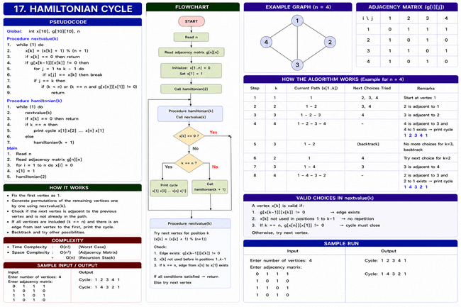

18. Matrix Chain Multiplication, Dynamic Programming Optimisation
#include<stdio.h>
#include<conio.h>
void main()
{
int p[10],m[10][10];
int i,j,k,n,q,len;
clrscr();
printf("Enter number of matrices: ");
scanf("%d",&n);
printf("Enter dimensions:\n");
for(i=0;i<=n;i++)
scanf("%d",&p[i]);
for(i=1;i<=n;i++)
m[i][i]=0;
for(len=2;len<=n;len++)
{
for(i=1;i<=n-len+1;i++)
{
j=i+len-1;
m[i][j]=9999;
for(k=i;k<j;k++)
{
q=m[i][k]+m[k+1][j]+p[i-1]*p[k]*p[j];
if(q<m[i][j])
m[i][j]=q;
}
}
}
printf("Minimum multiplication cost = %d",m[1][n]);
getch();
}
Output
Enter number of matrices: 3
Enter dimensions:
10 20 30 40
Minimum multiplication cost = 18000
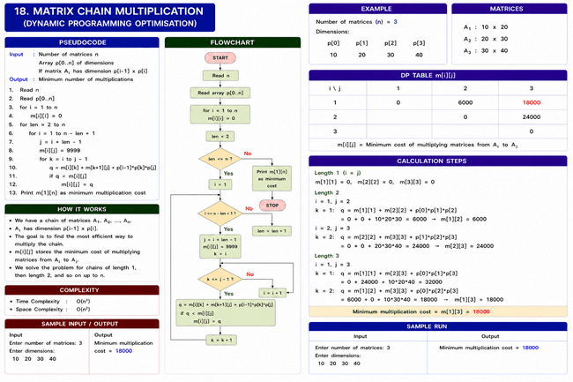
19. Optimal Merge Pattern, Greedy Optimisation
#include<stdio.h>
#include<conio.h>
void sort(int a[], int n)
{
int i, j, temp;
for(i=0; i<n-1; i++)
{
for(j=i+1; j<n; j++)
{
if(a[i] > a[j])
{
temp = a[i];
a[i] = a[j];
a[j] = temp;
}
}
}
}
void main()
{
int a[20], n, i, cost = 0, sum;
clrscr();
printf("Enter number of files: ");
scanf("%d", &n);
printf("Enter file sizes:\n");
for(i=0; i<n; i++)
scanf("%d", &a[i]);
while(n > 1)
{
sort(a, n);
sum = a[0] + a[1];
cost += sum;
a[1] = sum;
for(i=0; i<n-1; i++)
a[i] = a[i+1];
n--;
}
printf("Optimal Merge Cost = %d", cost);
getch();
}
Output
Enter number of files: 4
Enter file sizes:
20 30 10 5
Optimal Merge Cost = 115
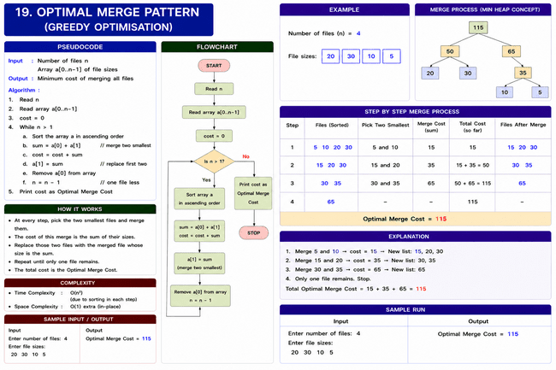

20. BFS, Graph Traversal
#include<stdio.h>
#include<conio.h>
int a[10][10], visited[10], queue[10];
int front=-1,rear=-1;
void bfs(int v,int n)
{
int i;
for(i=0;i<n;i++)
{
if(a[v][i]==1 && visited[i]==0)
{
rear++;
queue[rear]=i;
visited[i]=1;
}
}
if(front<=rear)
{
printf("%d ",queue[front]+1);
bfs(queue[front++],n);
}
}
void main()
{
int n, i,j, start;
clrscr();
printf("Enter number of vertices: ");
scanf("%d",&n);
printf("Enter adjacency matrix:\n");
for(i=0;i<n;i++)
{
for(j=0;j<n;j++)
{
scanf("%d",&a[i][j]);
}
}
for(i=0;i<n;i++)
visited[i]=0;
printf("Enter starting vertex: ");
scanf("%d",&start);
front=rear=0;
queue[rear]=start-1;
visited[start-1]=1;
printf("BFS Traversal: ");
printf("%d ",start);
bfs(start-1,n);
getch();
}
Output
Enter number of vertices: 4
Enter adjacency matrix:
0 1 1 0
1 0 1 1
1 1 0 0
0 1 0 0
Enter starting vertex: 1
BFS Traversal: 1 2 3 4
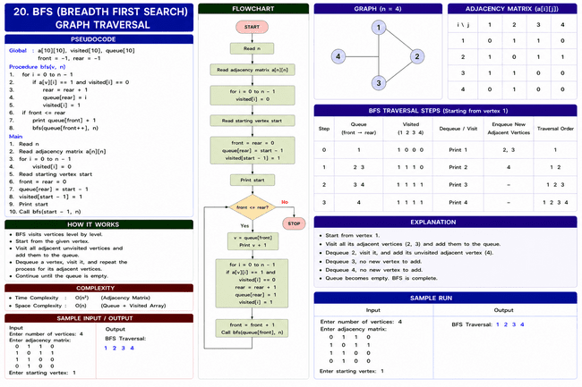
21. DFS, Graph Traversal
#include<stdio.h>
#include<conio.h>
int a[10][10], visited[10], n;
void dfs(int v)
{
int i;
visited[v]=1;
printf("%d ",v+1);
for(i=0;i<n;i++)
{
if(a[v][i]==1 && visited[i]==0)
dfs(i);
}
}
void main()
{
int i,j,start;
clrscr();
printf("Enter number of vertices: ");
scanf("%d",&n);
printf("Enter adjacency matrix:\n");
for(i=0;i<n;i++)
{
for(j=0;j<n;j++)
{
scanf("%d",&a[i][j]);
}
}
for(i=0;i<n;i++)
visited[i]=0;
printf("Enter starting vertex: ");
scanf("%d",&start);
printf("DFS Traversal: ");
dfs(start-1);
getch();
}
Output
Enter number of vertices: 4
Enter adjacency matrix:
0 1 1 0
1 0 1 1
1 1 0 0
0 1 0 0
Enter starting vertex: 1
DFS Traversal: 1 2 3 4
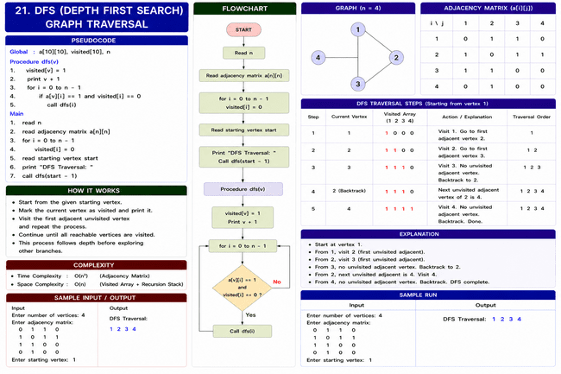

22. Travelling Salesman Problem, Branch and Bound
#include<stdio.h>
#include<conio.h>
int a[10][10], visited[10], n, cost = 0;
void tsp(int city)
{
int i, next;
int min = 999;
visited[city] = 1;
printf("%d -> ", city + 1);
for(i=0; i<n; i++)
{
if(a[city][i] != 0 && visited[i] == 0)
{
if(a[city][i] < min)
{
min = a[city][i];
next = i;
}
}
}
if(min == 999)
{
printf("1");
cost += a[city][0];
return;
}
cost += min;
tsp(next);
}
void main()
{
int i, j;
clrscr();
printf("Enter number of cities: ");
scanf("%d", &n);
printf("Enter cost matrix:\n");
for(i=0; i<n; i++)
{
for(j=0; j<n; j++)
{
scanf("%d", &a[i][j]);
}
}
for(i=0; i<n; i++)
visited[i] = 0;
printf("Path: ");
tsp(0);
printf("\nMinimum Cost = %d", cost);
getch();
}
Output
Enter number of cities: 4
Enter cost matrix:
0 10 15 20
10 0 35 25
15 35 0 30
20 25 30 0
Path: 1 -> 2 -> 4 -> 3 -> 1
Minimum Cost = 80
